IT 230 Final Project Part I – Console Register Student
Norman Whitney
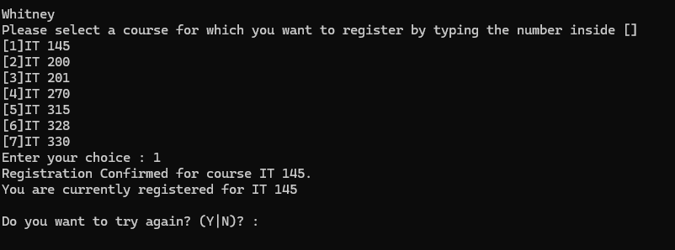
Screenshot 1 Description:
This screenshot demonstrates a valid course registration. The user selects course 1, and the program successfully registers the student for IT 145 and displays the current registration.
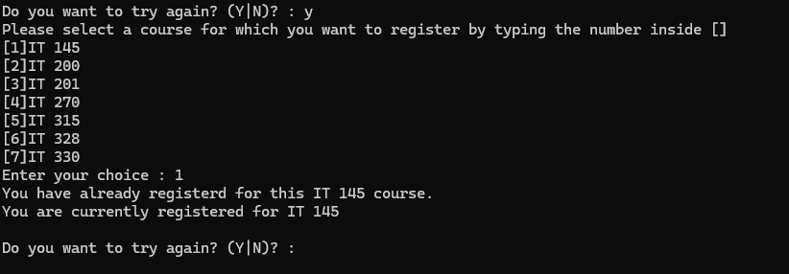
Screenshot 2 Description:
This screenshot demonstrates the duplicate course validation. The user attempts to register for IT 145 a second time, and the program prevents the duplicate registration and displays an error message.
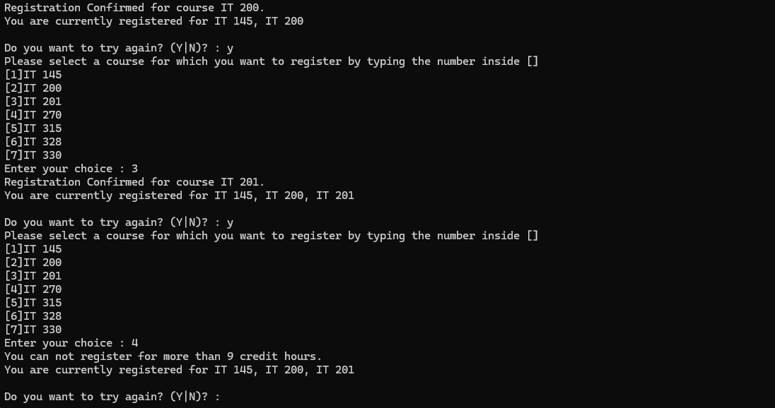
Screenshot 3 Description:
This screenshot demonstrates the nine-credit-hour registration limit. After the student has registered for three courses totaling nine credit hours, the program prevents registration for an additional course and displays an error message.
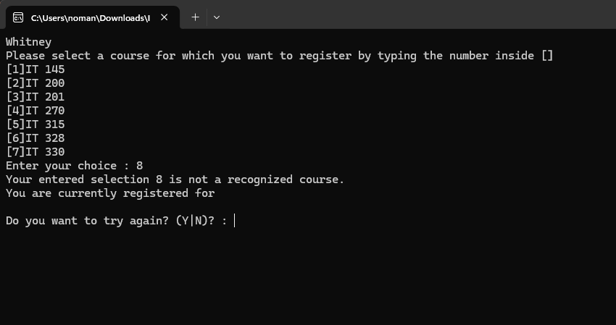
Screenshot 4 Description:
This screenshot demonstrates the invalid course selection validation. The user enters course selection 8, which is not included in the available course menu, and the program rejects the selection and displays an error message.

Source Code
using System;
using System.Collections.Generic;
using System.Linq;
using System.Text;
using System.Threading.Tasks;

namespace ConsoleRegisterStudent
{
class Program
{
static void Main(string[] args)
{
(new Program()).run();
}

void run()
{
int choice;
int firstChoice = 0, secondChoice = 0, thirdChoice = 0;
int totalCredit = 0;
string yesOrNo = "";

System.Console.WriteLine("Whitney");

do
{
WritePrompt();
choice = Convert.ToInt32(Console.ReadLine());

switch (ValidateChoice(choice, firstChoice, secondChoice, thirdChoice, totalCredit))
{
case -1:
Console.WriteLine("Your entered selection {0} is not a recognized course.", choice);
break;
case -2:
Console.WriteLine("You have already registerd for this {0} course.", ChoiceToCourse(choice));
break;
case -3:
Console.WriteLine("You can not register for more than 9 credit hours.");
break;
case 0:
Console.WriteLine("Registration Confirmed for course {0}.", ChoiceToCourse(choice));
totalCredit += 3;
if (firstChoice == 0)
firstChoice = choice;
else if (secondChoice == 0)
secondChoice = choice;
else if (thirdChoice == 0)
thirdChoice = choice;
break;
}

WriteCurrentRegistration(firstChoice, secondChoice, thirdChoice);
Console.Write("\nDo you want to try again? (Y|N)? : ");
yesOrNo = (Console.ReadLine()).ToUpper();
} while (yesOrNo == "Y");

Console.WriteLine("Thank you for registering with us");
}

void WritePrompt()
{
Console.WriteLine("Please select a course for which you want to register by typing the number inside []");
Console.WriteLine("[1]IT 145\n[2]IT 200\n[3]IT 201\n[4]IT 270\n[5]IT 315\n[6]IT 328\n[7]IT 330");
Console.Write("Enter your choice : ");
}

int ValidateChoice(int choice, int firstChoice, int secondChoice, int thirdChoice, int totalCredit)
{
if (choice < 1 || choice > 7)
return -1;
else if (choice == firstChoice || choice == secondChoice || choice == thirdChoice)
return -2;
else if (totalCredit >= 9)
return -3;
return 0;
}

void WriteCurrentRegistration(int firstChoice, int secondChoice, int thirdChoice)
{
if (secondChoice == 0)
Console.WriteLine("You are currently registered for {0}", ChoiceToCourse(firstChoice));
else if (thirdChoice == 0)
Console.WriteLine("You are currently registered for {0}, {1}", ChoiceToCourse(firstChoice), ChoiceToCourse(secondChoice));
else
Console.WriteLine("You are currently registered for {0}, {1}, {2}", ChoiceToCourse(firstChoice), ChoiceToCourse(secondChoice), ChoiceToCourse(thirdChoice));
}

string ChoiceToCourse(int choice)
{
string course = "";
switch (choice)
{
case 1:
course = "IT 145";
break;
case 2:
course = "IT 200";
break;
case 3:
course = "IT 201";
break;
case 4:
course = "IT 270";
break;
case 5:
course = "IT 315";
break;
case 6:
course = "IT 328";
break;
case 7:
course = "IT 330";
break;
default:
break;
}
return course;
}
}
}

